
Symbiosis Institute of Technology, Pune
CSE- Academic Year 2026-27
Java Programming – Lab Batch 2025-29
Lab Assignment No.:
Name of Student | Akshit Gawade
PRN No. | 25070122029
Batch | 2025-2029
Class | A1
Academic Year & Semester | Second Year  Semester III
Date of Submission | 11/7/2026
Title of Assignment: | Write a Java program to demonstrate the use of abstract classes and abstract methods.
Problem Statement  Learning Objectives | Write a Java program to demonstrate the use of abstract classes and abstract methods.  To implement abstraction using abstract classes and abstract methods.
Theory | Abstract classes provide partial implementation and abstract methods must be implemented by subclasses. Abstraction hides implementation details while exposing essential functionality.
Program Code | EX1  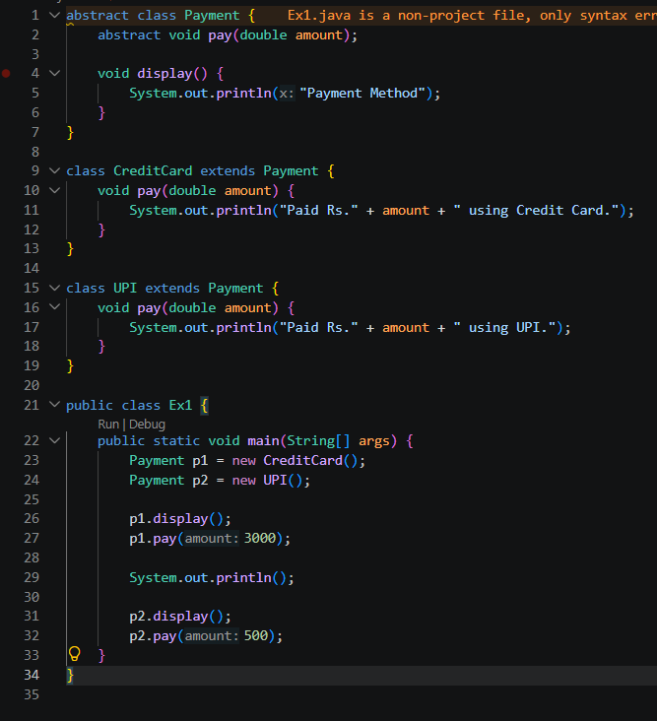  EX2  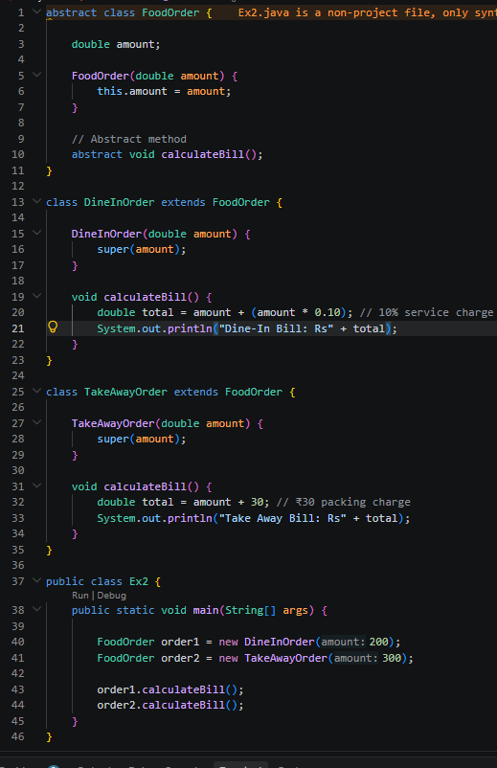
Output Screenshots | Ex1  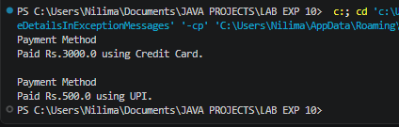  Ex2  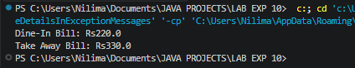
Conclusion | This assignment helped in understanding the concepts of abstract classes and abstract methods in Java. It demonstrated how abstraction hides implementation details while exposing only the essential functionality, allowing subclasses to provide their own implementations of abstract methods. The implementation improved my understanding of object-oriented programming principles such as abstraction, inheritance, and polymorphism, resulting in more flexible and maintainable code. These concepts are widely used in developing desktop applications, web applications, Android applications, enterprise software, banking systems, and other real-world Java applications that require reusable, modular, and scalable software design.

